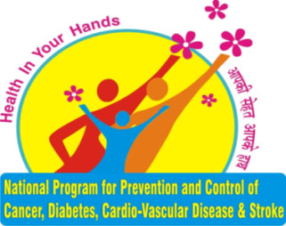

Report on
National Programme for Prevention and Control of Cancer, Diabetes, Cardiovascular Diseases and Stroke (NPCDCS)

INTRODUCTION
India is experiencing rapid demographic and epidemiological transitions with Non-Communicable Diseases (NCDs) causing significant disability, morbidity and mortality both in urban and rural populations and across all socioeconomic strata. The four identified major NCDs are Cardiovascular Diseases such as heart attacks and stroke, Diabetes, Chronic Respiratory Diseases (Chronic Obstructive Pulmonary Diseases and Asthma) and Cancer. According to the WHO’s Country Profile for India, 2014NCDs were estimated to cause approximately 60% of all deaths in India. One in four Indians carry the risk of dying prematurely due to NCDs ( between the ages of 30 and 70 yrs).This rising trend of NCDs is closely associated with the higher prevalence of NCD risk factors. NCDs are associated with multiple co morbidities and require lifelong care. These diseases by and large can be prevented by making simple changes in the way people live their lives or simply by changing the lifestyle.
The most NCDs are strongly associated and causally linked with four major behavior risk factors like (i) Tobacco use, (ii) Physical inactivity, (iii) Unhealthy diet including high intake of salt, sugar & trans fats and low intake of fruits and vegetables, (iv) Harmful use of alcohol. The other risk factors include stress and household air pollution. If these behavioral risk factors are not managed or modified then they may lead to biological risk factors such as (i) Overweight, (ii) High blood pressure, (iii) Raised blood sugar and (iv) Raised total cholesterol or lipids .The other non-modifiable risk factors such as age, sex and heredity are also associated with the occurrence of NCDs.
In view of the increasing burden of Non-Communicable Diseases, Ministry of Health and Family Welfare, Government of India launched the National programme for Prevention and Control of Cancer, Diabetes, Cardiovascular Diseases and Stroke (NPCDCS) in 2010. The focus of the programme is on health promotion and prevention, strengthening of infrastructure including human resources, early diagnosis and management and integration with the primary health care system. The NPCDCS aims to integrate the activities under the umbrella of National Health Mission.
In Sikkim, NPCDCS Programme was initiated at East and South districts during the FY2010-11 and the programme has been extended to all districts of Sikkim. The programme is managed through State NCD cell and district levels to ensure implementation and supervision of programme activities. The NCD cells serve as focal point for monitoring and reporting of performance of NPCDCS activities .All district hospitals have regular NCD clinic for early diagnosis, counseling, treatment and referral and NCD screening are done through Frontline Health Workers at community level as well as through outreach activities.
For the implementation of the NPCDCS programme the Government of India is providing technical, financial and logistics support within the NHM framework for activities at the district level and below.

OBJECTIVE:
The overall objective of the programme is to prevent and control the common NCDs.

STRATEGIES:
- Health promotion: Major determinants of Hypertension, overweight/obesity, high blood glucose.
- Early diagnosis and treatment.
- Establishment/Strengthening of Health Infrastructure.
- Integration with AYUSH.
- Surveillance, Monitoring and Evaluation.

India Hypertension Control Initiative (IHCI)
India is facing the rising burden of non-communicable diseases (NCDs) in general and hypertension in specific. The National Programme for Prevention and Control of Cancer, Diabetes, Cardiovascular diseases and Stroke (NPCDCS) has given due recognition to this and has set a goal of 25% reduction in mortality due to non-communicable diseases by 2025. NPCDCS has initiated a population-based screening program (PBS) for hypertension, diabetes, and cancers of the breast, cervix and oral cavity. India Hypertension Control Initiative (IHCI), a multi-partner initiative, complements this screening program by strengthening the management of hypertension in primary health care settings. It aims to accelerate progress towards the Government of India's NCD target by supplementing and intensifying evidence based strategies towards strengthening the building blocks of hypertension management and control. IHCI partners include the Ministry of Health & Family Welfare, Government of India, State Governments, Indian Council of Medical Research (ICMR) and World Health Organization (WHO) India. Resolve to Save Lives, an initiative of Vital Strategies, is a technical partner.
India Hypertension Control Initiative (IHCI) was launched in Sikkim on 1st April 2021 in East Sikkim and South Sikkim .
The Objective: The objective of IHCI programme is to strengthen the hypertension treatment component till community level and to accelerate implementation of quality treatment for hypertension among Indians and prevent deaths from heart attack, stroke and kidney failure IHCI major aim is to build competencies of health professionals at the primary health care level to treat hypertension as per the standard state-specific treatment protocol using a patient-centric approach. IHCI aims to build capacity for strengthening drug logistic systems at the district and health facility levels. Additionally, IHCI provides strategies and guiding principles for information systems, monitoring and supervision of the hypertension control programme. It should be considered a supplement to the existing training materials for different cadres of health care providers under the NPCDCS. Team-based training at the primary health care level such that all members are aware of the entire team’s roles to ensure the best outcomes for the patient as well as for control of hypertension in their areas. The action plan of IHCI is to intervene decentralization of medicine supply to PHSC from PHC .The following information are collected from PHSC such as number of Hypertensive patients, number of patients on follow up so that medicine forecast can be done for 3 months per PHSC. IHCI Sikkim aims to map all the patients of South and East Sikkim who are on follow up under NPCDCS programme through registration in the simple app.
Physical Performance: IHCI has registered 514 patients in East Sikkim and 496 patients in South Sikkim. The medicine supply for the PHC is streamlined from the District NCD Office. The medicines are provided by assumption of 100 patients per PHC with buffer stock of 3 months. It has been planned to launch IHCI in North and West Districts in the month of November 2021.

IHCI DATA OF 2021-22
S. No | Particulars | Hypertension | Diabetes Mellitus
1. | No. of patients enrolled * | 1405 (Till 10th Aug 2021 ) | NA
2. | Follow up – % of total patients followed up in previous month | 62% | NA
3. | Percentage of patients with Missed visit** | 38%
4. | Percentage of patients Lost to follow up | 0%
5. | Number of patients with BP under control (April-June 2021) | 98
6. | Control rate by type of facility | DH/SDH/CHC-21%
 |  | PHC/UPHC – 69%
 |  | HWC-SC/SCs – 10%
7. | Percentage of HWCs delivering IHCI services | 51%
8. | Percentage of health facilities having adequate (minimum 30 days stock) 1st line protocol drug stocks | 90-95% | 10th AUG 2021
9. | Percentage of health facilities having adequate (minimum 30 days stock) 2nd line protocol drug stocks | 90% | 10th AUG 2021

Training On NPCDCS
Sl. No | Activities | 2020-21 | 2021-22 (till Aug 2021)
 | Training | - 24(Medical Officer &DPM, BPM, DEO)  - 65 ANM &MLHP of West & South Districts | ●36 ( Training on Asha)
 | Screenings & Forms Filled | - No. of People enumerated: 109647  - No of People Screened: 49326  - CBAC Fill : 58143 | - No. of People enumerated: 14365  - No of People Screened: 17989  - CBAC Fill : 13,359

NCD CLINIC DATA
 | Activities |  | 2020-21 | 2021-22 (till Aug 2021)
 | No. of patients attend in NCD OPD |  | 38985 | 17989
 | New Patients Diagnosed with | Diabetes (DM) | 1021 | 296
 |  | Hypertension (HTN) | 2009 | 783
 |  | HTN &DM | 468 | 164
 |  | Cardiovascular Diseases (CVDs | 28 | 8
6. | Persons put on Treatment | DM | 854 | 2216
 |  | HTN | 1653 | 6065
 |  | HTN & DM | 401 | 1754
 |  | CVDs | 27 | 67
7. | No. of person treated at CCU | CVDs | 14 | 5
 |  | Stroke | 40 | 1

One day Oritentation Training Programme cum- Cordination meeting on NPCDCS for Medical & MLH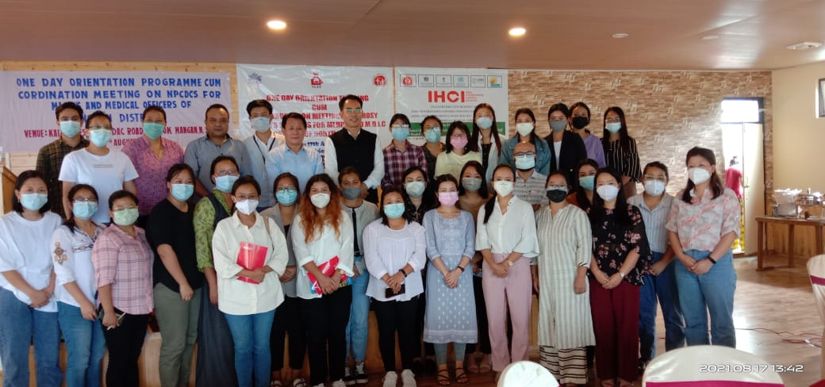Ps
IHCI ONE DAY TRAINING FOR MLHPs& M.O
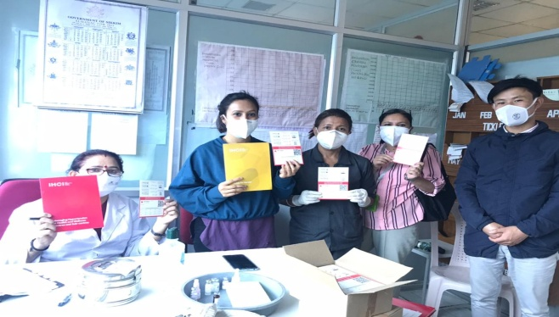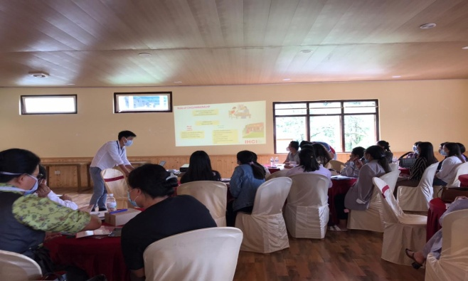
Training of ASHA on Scaling up of implementation of Primary HPV Screening by Self Sampling
